READING WEBSITES
Razkids
Starfall
Into the Book
Seussville
Scholastic
Storyline Online
Spelling Lists & Practice

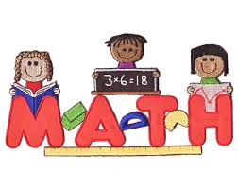

MATH WEBSITES
Mobymax
Extra Math
Math is Fun!
Fun 4 the Brain
Math Fact Practice & More!
Starfall
BrainPOP
Math Magician

SOCIAL STUDIES & SCIENCE
National Geographic for Kids
Time for Kids
Kids Health
Fact Monster (Inventions & Technology)
White House for Kids
BrainPOP

