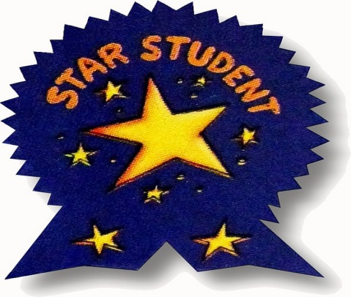
During the year, every student will be recognized as a STUDENT OF THE WEEK. A large "Read All About Me" worksheet will be sent home on Friday for the student to complete by the following Monday. During the week, the class and I will interview your child. Please encourage your child to bring in any favorite pictures, books, or something special (nothing expensive or fragile) that will help us learn more about them.

